慧谷嘉园公租房项目空置房及户型图

|  |  |  |  |  |
| --- | --- | --- | --- | --- |
| **序号** | **单元编号** | **建筑面积** | **户型** | **备注** |
| 1 | 2-1-203 | 54 | 一室一厅 |  |
| 2 | 2-1-305 | 54.05 | 一室一厅 |  |
| 3 | 2-1-503 | 54 | 一室一厅 |  |
| 4 | 2-1-505 | 54.05 | 一室一厅 |  |
| 5 | 2-1-701 | 62.46 | 两室一厅 |  |
| 6 | 2-1-706 | 61.34 | 两室一厅 |  |
| 7 | 2-1-801 | 62.46 | 两室一厅 |  |
| 8 | 2-1-803 | 54 | 一室一厅 |  |
| 9 | 2-1-805 | 54.05 | 一室一厅 |  |
| 10 | 2-1-806 | 61.34 | 两室一厅 |  |
| 11 | 2-1-1001 | 62.46 | 两室一厅 |  |
| 12 | 2-1-1002 | 64.04 | 两室一厅 |  |
| 13 | 2-1-1005 | 54.05 | 一室一厅 |  |
| 14 | 2-1-1103 | 54 | 一室一厅 |  |
| 15 | 2-1-1104 | 43.19 | 厅室合一 |  |
| 16 | 2-1-1206 | 61.34 | 两室一厅 |  |
| 17 | 2-1-1301 | 62.46 | 两室一厅 |  |
| 18 | 2-1-1305 | 54.05 | 一室一厅 |  |
| 19 | 2-1-1401 | 62.46 | 两室一厅 |  |
| 20 | 2-1-1403 | 54 | 一室一厅 |  |
| 21 | 2-1-1404 | 43.19 | 厅室合一 |  |
| 22 | 2-1-1603 | 54 | 一室一厅 |  |
| 23 | 2-1-1801 | 62.46 | 两室一厅 |  |
| 24 | 2-1-2101 | 62.46 | 两室一厅 |  |
| 25 | 2-2-101 | 62.02 | 两室一厅 |  |
| 26 | 2-2-102 | 54.05 | 一室一厅 |  |
| 27 | 2-2-301 | 61.34 | 两室一厅 |  |
| 28 | 2-2-402 | 54.05 | 一室一厅 |  |
| 29 | 2-2-404 | 54 | 一室一厅 |  |
| 30 | 2-2-502 | 54.05 | 一室一厅 |  |
| 31 | 2-2-706 | 62.46 | 两室一厅 |  |
| 32 | 2-2-1001 | 61.34 | 两室一厅 |  |
| 33 | 2-2-1002 | 54.05 | 一室一厅 |  |
| 34 | 2-2-1006 | 62.46 | 两室一厅 |  |
| 35 | 2-2-1104 | 54 | 一室一厅 |  |
| 36 | 2-2-1202 | 54.05 | 一室一厅 |  |
| 37 | 2-2-1702 | 54.05 | 一室一厅 |  |
| 38 | 2-2-1906 | 62.46 | 两室一厅 |  |
| 39 | 2-2-2002 | 54.05 | 一室一厅 |  |

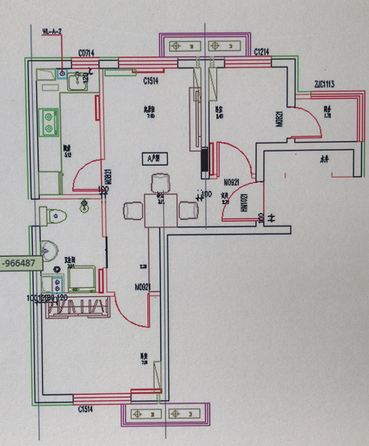

A户型：两室一厅

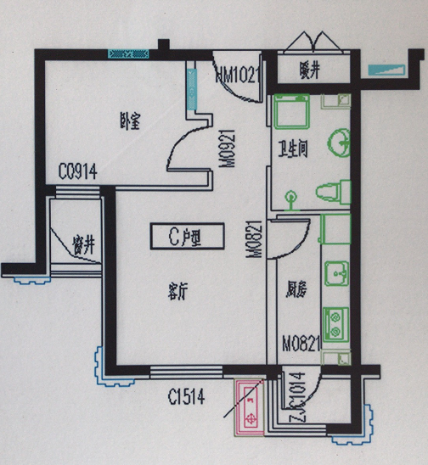

C户型：一室一厅

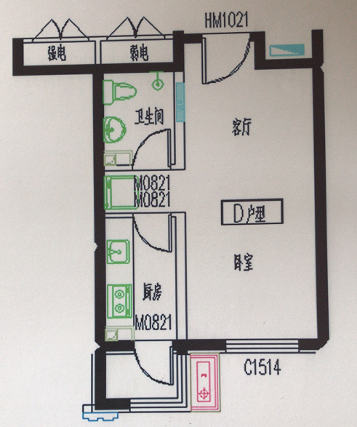

D户型：厅室合一